# Project Progress for Group 3

Group Name: Duolingo

Group Members:

1. Cheong Yie Shen Hewitt 103516128
2. Tiong Qi Xuan 103542576

## Project Process Book Progress

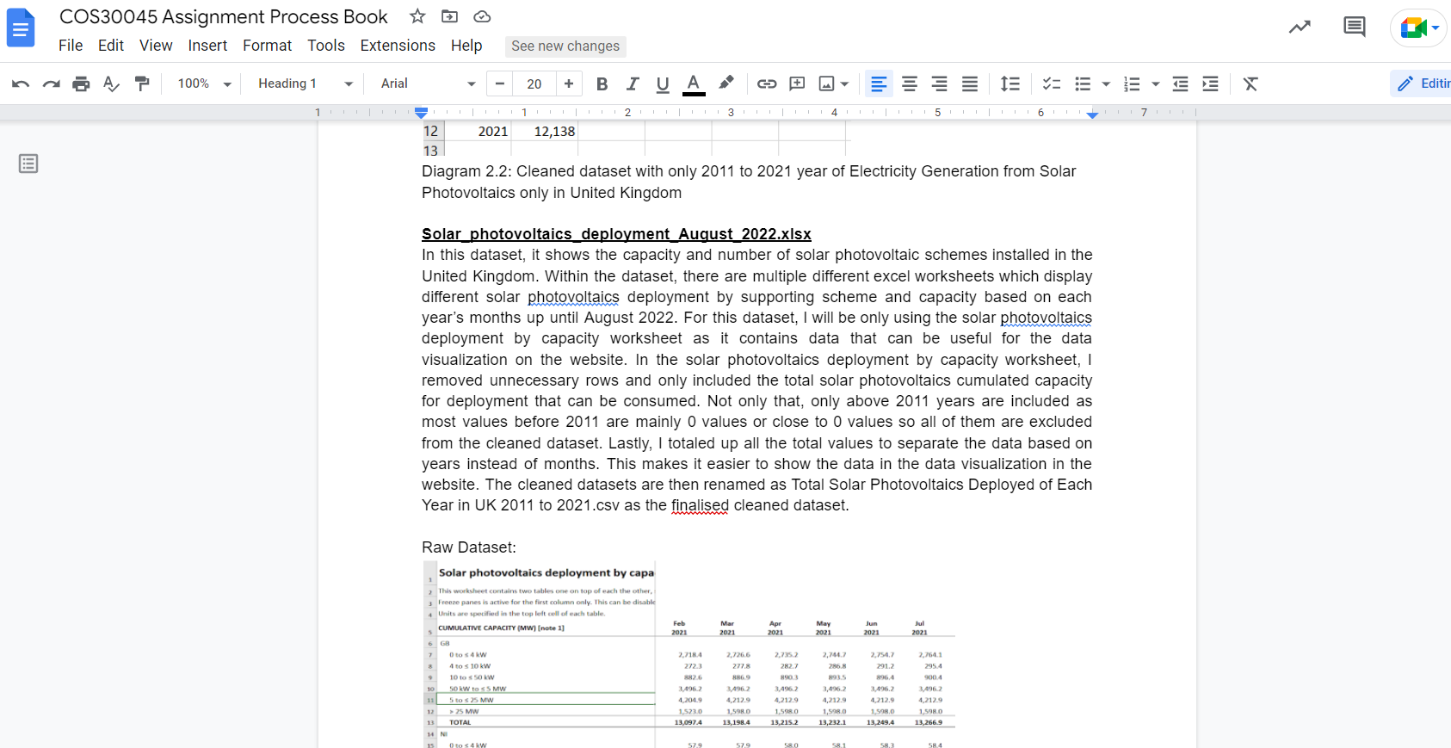

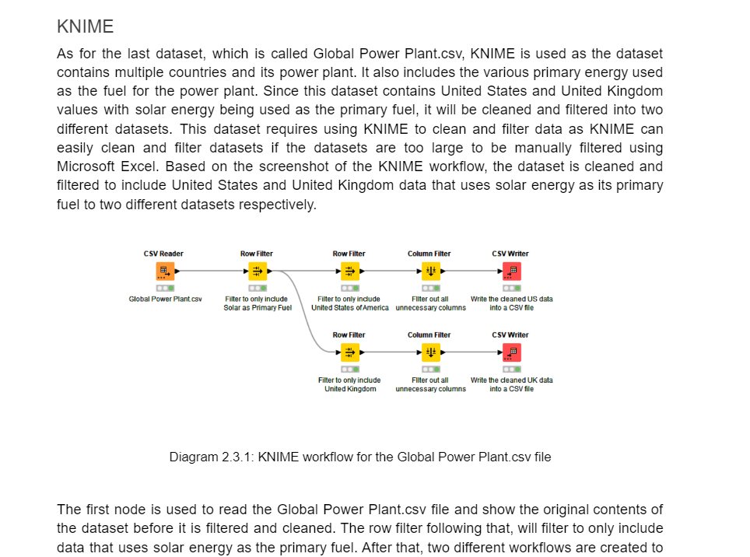

## Cleaned Datasets Screenshots

### United States Cleaned Datasets

***Global Power Plant.csv***

Raw Data:

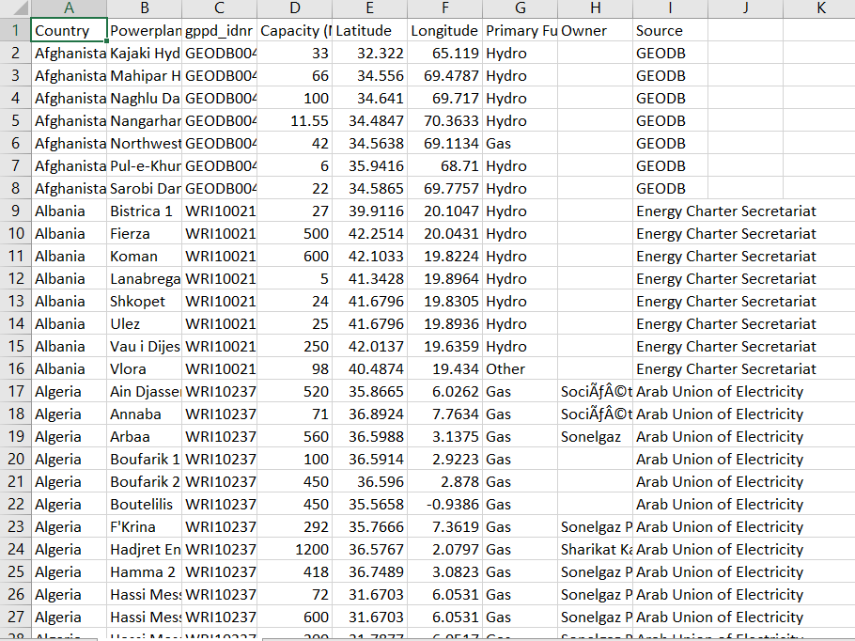

Cleaned Dataset:

US

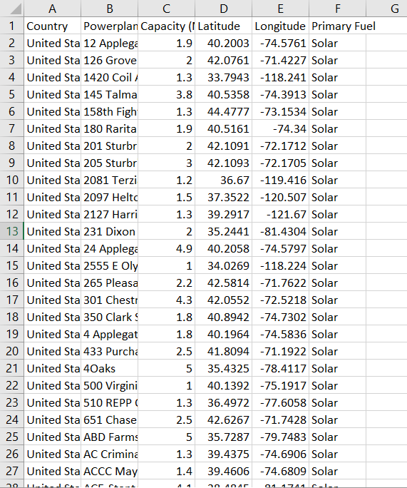

UK

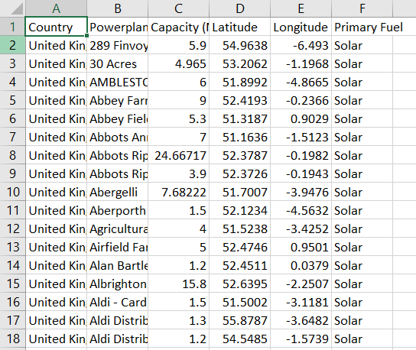

## Data Visualisation Designs

### Choropleth

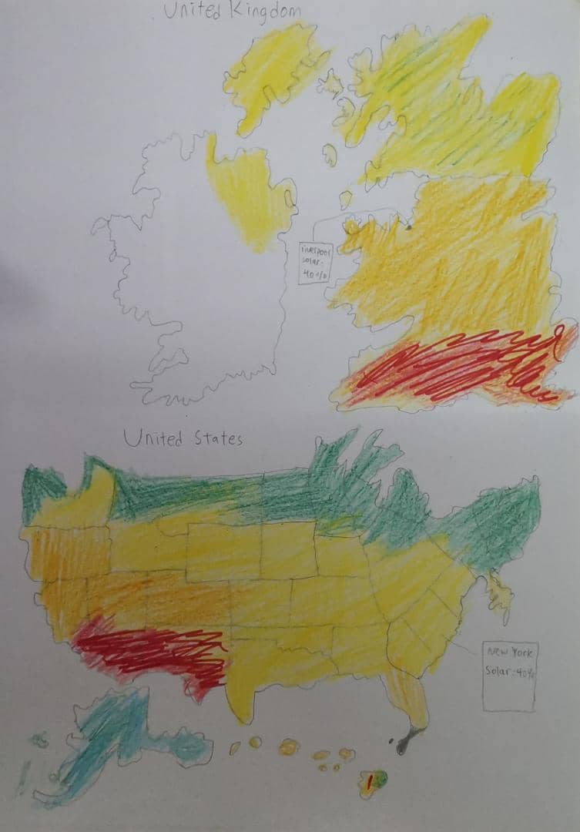

## Website Progress

### Line Chart in Progress

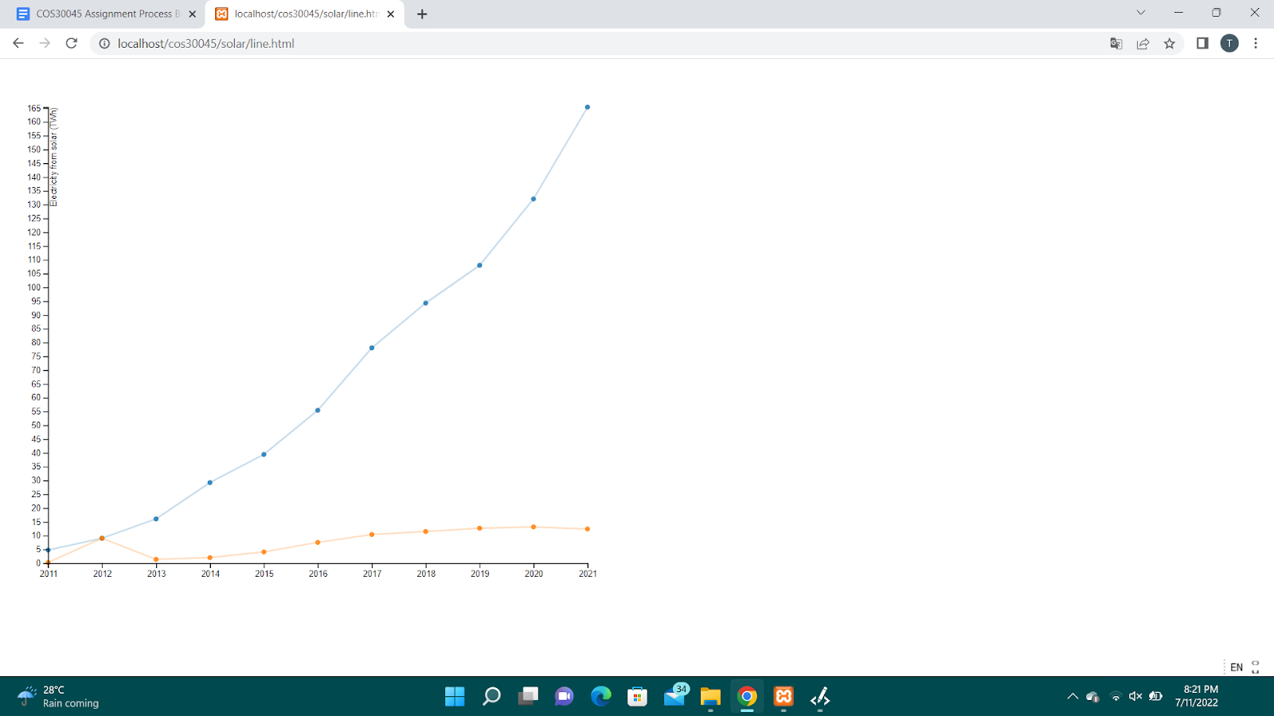

### Bar Chart In Progress

